PinePG Plugin For Magento Online Store Document

# Contents

DESCRIPTION..............................................................................................................3

SERVER SUPPORTS 7

HOW TO ADD PLUGIN 7

PLUGIN CONFIGURATION 8

# description

1.This is the PinePG Payment Gateway plugin for your Magento store. Securely accept Debit Cards, Credit Cards.Do payment using Net Banking, Rewards Points, EMI.

2.In Payment Information there will be an option of PinePG.

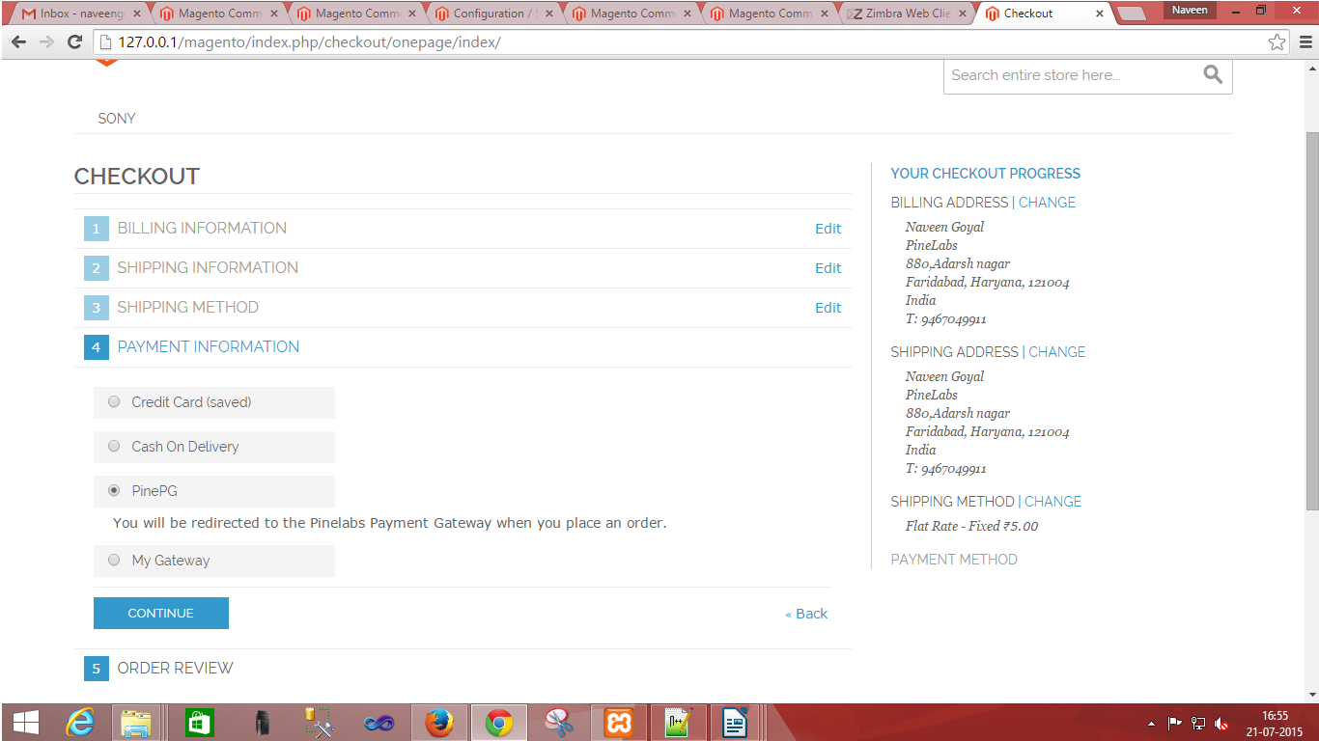

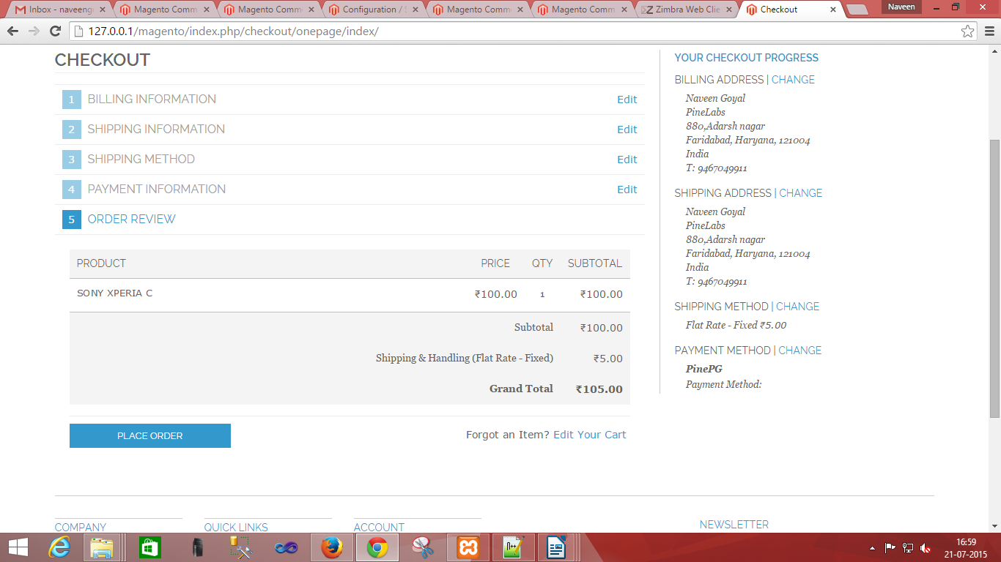

3. You will be redirected to PinePG Payment Gateway when click on PLACE ORDER. After That you will see following screen of PinePG payment gateway.

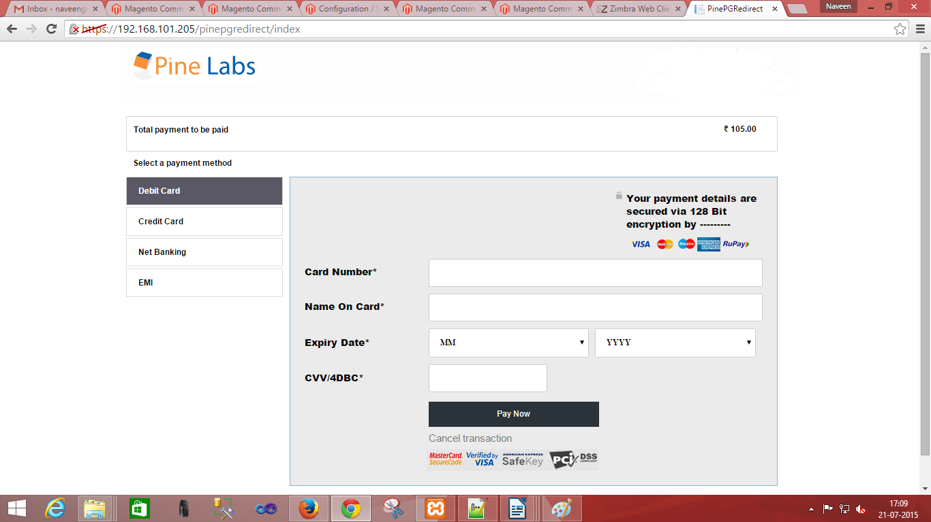

4. Transaction will be processed by PinePG payment gateway.And payment response will be received on your website.

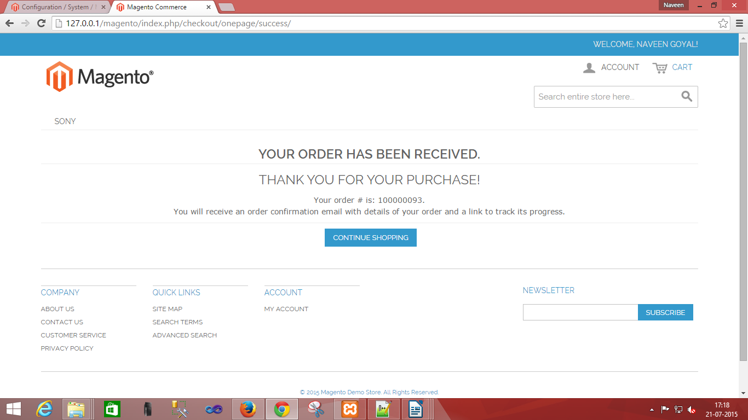

# Server Support

 1. You should have apache web server or any other compatible server.

2. You should have MySql Database Server.

# HOW TO ADD PLUGIN

1. There are three .zip files in PineLabs_Plugin folder . I) PineLabs.zip II)PinePG.zip III)PineLabs_PinePG.zip.

2. Extract PineLabs.zip in app/code/local.

3. Extract PinePG.zip in app/design/frontend/base/default/template.

4. Extract PineLabs_PinePG.zip in app/etc/modules.

# PLUGIN CONFIGURATION

1. Now you will have to save configuration on your website. Go to 127.0.0.1/magento/index.php/admin or http://yourwebsite.com/admin and logged in. Then go to System->Configuration->ADVANCED->Advanced->Save config. Now You will see your Plug-in name (PineLabs_PinePG.xml) on screen. If this is disable then you will have to Enable it.



2. Now You will have to enable PinePG and enter all merchant information that was given by PineLabs.

Goto->System->Configuration->Sales->Payment Methods->PinePG and enable the PinePG and enter valid merchant information and secret_key.

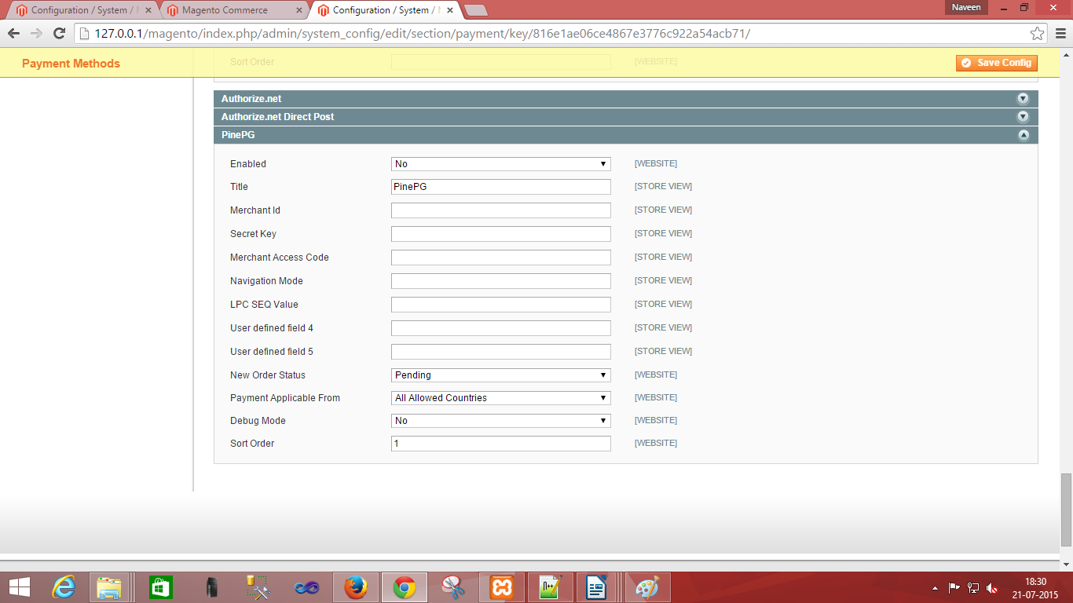

3. After Filling, all fields you will have to go Save config.

Now payments can be processed using Pine Labs Payment Gateway- PinePG.